Template layout - Resolution specific stylesheets
The CUE template uses resolution specific stylesheets to achieve a resolution independent layout (a layout that works well regardless of window size, text size or device resolution).

Discussion and rationale
There has been much discussion about approaches to layout. The discussion and the rationale for using CSS media queries to implement an adaptable layout is summarised here:
- I designed the page a certain way. The visual relationships between content are broken if the third column wraps underneath.
Visual relationships must be supported by relationships expressed through markup or content (WCAG2 Guideline 1.3). If the relationship can be determined through the markup or content, then the visuals change at low resolutions without loss of meaning. See Appendix 1 - Separation of content and presentation.
- Most websites these days use a fixed width layout, we should do the same.
Fixed with websites (and websites with a minimum width) introduce horizontal scrollbars at lower resolutions. Horizontal scrollbars should be avoided unless absolutely necessary. The Queensland Government CUE has always featured a template with floated columns that linearise to two, then one column at lower resolutions. This approach supports lower resolutions without introducing a horizontal scrollbar.
- We could force the layout to remain a three column layout at all resolutions.
This approach means the columns become seriously compressed at lower resolutions leaving the content inaccessible.
- We could introduce a minimum width for the layout so the columns don't compress too far
This approach carries similar risks to the fixed width approach above, horizontal scrollbars are introduced at low resolutions
- Users may be confused if the website looks different on one computer than another computer. Users may be confused if they resize their window and the layout changes.
This is not uncommon behaviour for flexible width layouts. As CSS media queries become mainstream and mobile devices proliferate in the near future, we will see many more sites taking this approach. The benefits of supporting all resolutions and devices outweigh potential confusion in these situations.

References
- http://www.themaninblue.com/writing/perspective/2004/09/21/
- http://www.themaninblue.com/writing/perspective/2006/01/19/
- http://www.456bereastreet.com/archive/200511/resolution_dependent_style_switching/
- http://particletree.com/features/dynamic-resolution-dependent-layouts/
- http://www.alistapart.com/articles/switchymclayout/
- http://css-tricks.com/resolution-specific-stylesheets/
- http://www.protofunc.com/scripts/jquery/mediaqueries/
- http://www.w3.org/TR/css3-mediaqueries/
- http://www.w3.org/TR/WCAG20/ (Checkpoints 1.3.1, 1.3.2, 1.3.3, 1.4.4 and 1.4.8 (part 5.))

Appendix 1 - Separation of content and presentation
All content and relationships between content must remain meaningful if you remove the CSS!
In the example of http://climate.nasa.gov/causes/ related information boxes are placed to the right of passages of content they are related to.
This page uses tables for layout (nested three or four tables deep), so when linearised by assistive technology (like a screen reader) the relationship between content and related box is lost.
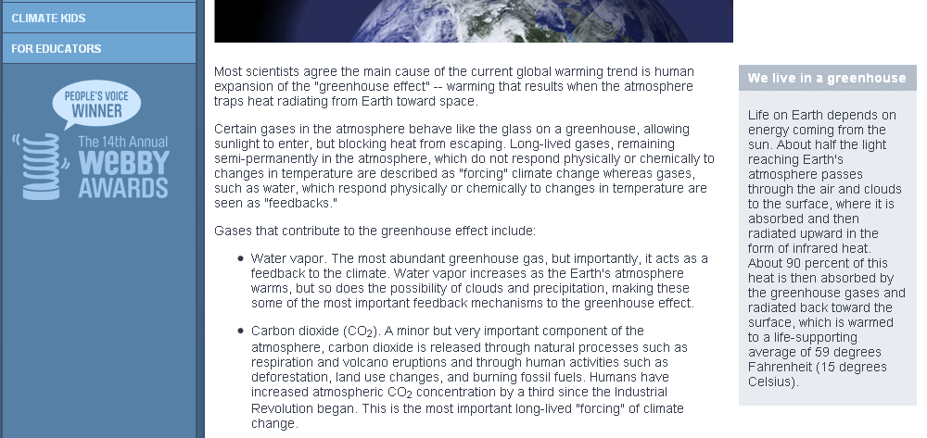
If the related boxes were added to the 'asides' column of the CUE template and visually positioned in line with the content on the left, again the relationship is visual only, and inaccessible for users of some assistive technologies.
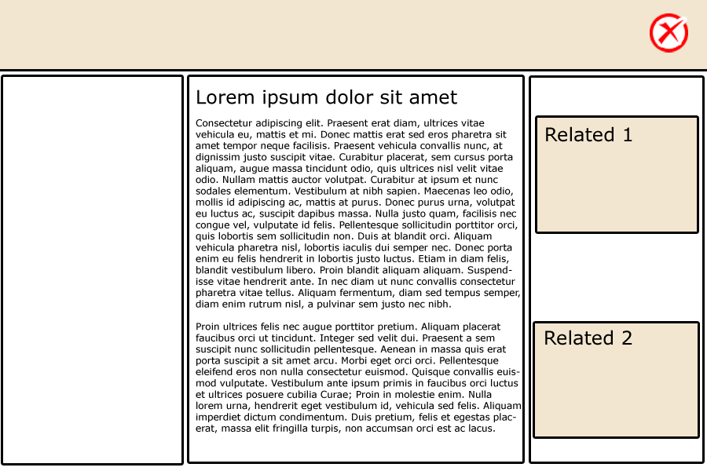
As this layout resizes down, the asides column drops under and now the visual relationship is lost also. This only exposes the lack of a semantic relationship to support the visual relationship.

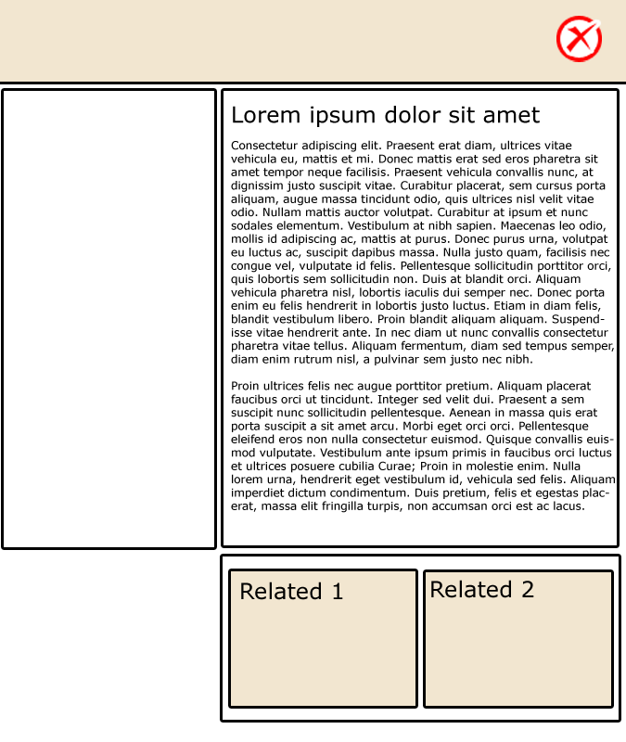
Note: For pages where the 'asides' are related to the content page as a whole, this semantic relationship is perfectly valid. It's only when we want to establish a relationship from a related box to a specific section of content that this approach is not accessible.

An accessible solution
It's important to realise that accessibility requirements rarely prohibit a particular visual effect or visual relationship; we just have to be creative in how we implement the effect. In particular, we need to ensure that visual relationships are supported by semantic relationships (relationships in the markup or content) (WCAG2 Guideline 1.3).
The best way to approach this is to:
- Create a visual design (Photoshop, Fireworks, other)
- Think about the important visual relationships you have designed and how they can be implied in the markup or content.
- Think about how you can take that markup and create the visual effect you are looking for.
In this example, if we remove the asides column, and float the related boxes to the right of the content (with a max-width on the content elements) we can achieve the same visual effect while retaining the relationship between the content and the boxes because they remain near each other in the markup.
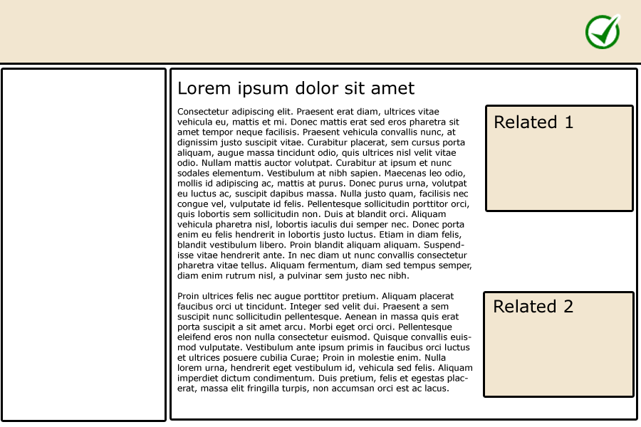
As the page is resized down, the related boxes will fold into the content and the text will wrap around them. The relationships are maintained, but the layout can still be flexible and adapt to the current resolution.
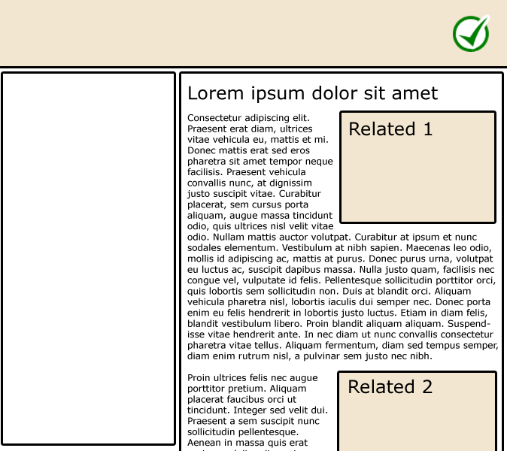
Note: This approach is only suitable when the boxes relate to a section of content. If the boxed information is related to the overall page content, it is more appropriate for this content to appear in the 'asides' as its own column. The 'asides' column is then free to fold under the main content at some resolutions because the relationship still makes sense when linearised.

